**Linear Classification**

A classification algorithm (Classifier) that makes its classification based on a linear predictor function combining a set of weights with the feature vector.

Decision boundary is flat Line, plane

May involve non - linear operations

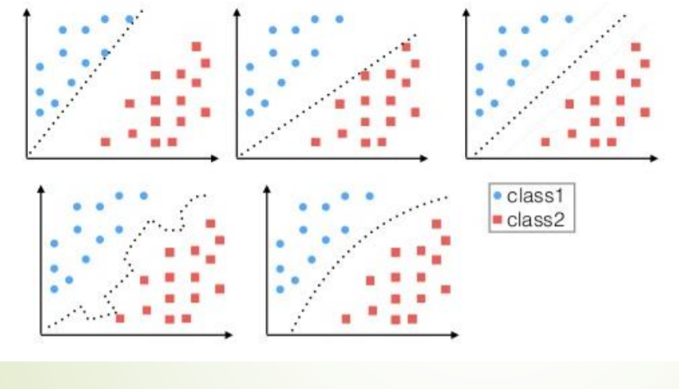

Different approaches -

* Explicitly creating the discriminant function (Discriminant function)
  + Perceptron
  + Support vector machine
* Probabilistic approach
  + Model the posterior distribution
  + Algorithms -> Logistic regression

Discriminant functions ->

Two classes:

y (𝑋) = 𝑤𝑇(𝑋) + 𝑤0

More than two classes (K classes):

There are K indicators 𝑌𝑘 = 1 if G = K, else 0 𝑌 = 𝑌1, … , 𝑌𝐾 Example: (0,0,1,0) for a feature in class 3 when there are 4 classes!

Probabilistic approaches ->

Determine the class-conditional densities for each class

Bayes’ theorem:

